Connor Medeiros

Final Project Part 2

IT-230

Professor Johnathan Norman

Southern New Hampshire university

August 2025

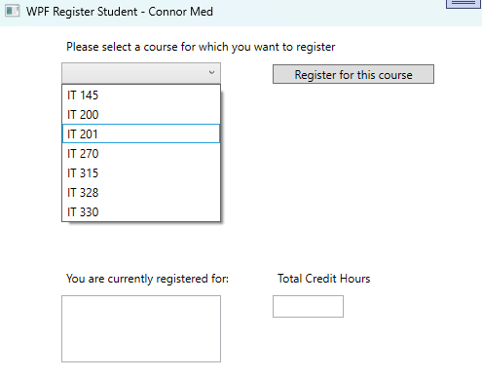

1. Screenshot Description . The WPF application main window showing the title “WPF Register Student - Connor Medeiros” with the ComboBox dropdown visible, no courses registered, and Total Credit Hours empty.

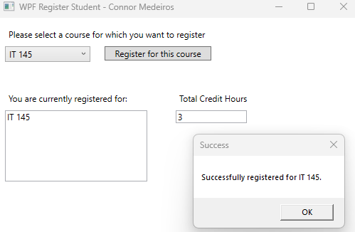

1. Screenshot Description: Select “IT 145” from the ComboBox and click “Register for this course”. 3 credit hours are added to “total credit hours” box.

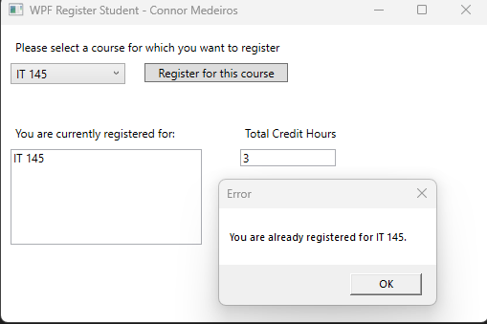

1. Screenshot Description: Tried registering IT 145 again to trigger an error message.

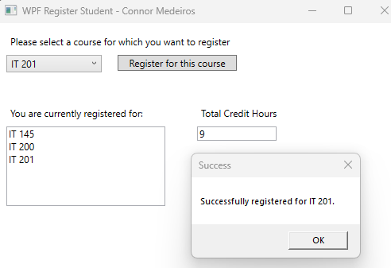

1. Screenshot Description: Successfully register IT 200 and IT 201 for a total of 9 credit hours.

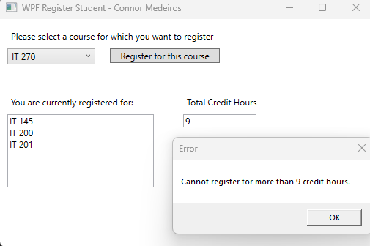

1. Screenshot Description: Tried registering a fourth course (e.g., IT 270) to trigger an error.

**Source Code**

**A . Course.cs**

namespace WPFRegisterStudent

{

public class Course

{

public string Title { get; set; }

public Course(string title)

{

this.Title = title;

}

public override string ToString()

{

return Title;

}

public override bool Equals(object obj)

{

if (obj == null || GetType() != obj.GetType())

return false;

Course c = (Course)obj;

return this.Title == c.Title;

}

public override int GetHashCode()

{

return Title.GetHashCode();

}

}

}

**B. MainWindow.xaml**

**using System;**

**using System.Collections.Generic;**

**using System.Linq;**

**using System.Windows;**

**using System.Windows.Controls;**

**namespace WPFRegisterStudent**

**{**

**public partial class MainWindow : Window**

**{**

**Course choice;**

**List<Course> registeredCourses = new List<Course>();**

**int totalCreditHours = 0;**

**public MainWindow()**

**{**

**InitializeComponent();**

**}**

**private void Window_Loaded(object sender, RoutedEventArgs e)**

**{**

**Course course1 = new Course("IT 145");**

**Course course2 = new Course("IT 200");**

**Course course3 = new Course("IT 201");**

**Course course4 = new Course("IT 270");**

**Course course5 = new Course("IT 315");**

**Course course6 = new Course("IT 328");**

**Course course7 = new Course("IT 330");**

**this.comboBox.Items.Add(course1);**

**this.comboBox.Items.Add(course2);**

**this.comboBox.Items.Add(course3);**

**this.comboBox.Items.Add(course4);**

**this.comboBox.Items.Add(course5);**

**this.comboBox.Items.Add(course6);**

**this.comboBox.Items.Add(course7);**

**this.textBox.Text = "";**

**}**

**private void button_Click(object sender, RoutedEventArgs e)**

**{**

**if (comboBox.SelectedItem == null)**

**{**

**MessageBox.Show("Please select a course to register.", "Error");**

**return;**

**}**

**choice = (Course)comboBox.SelectedItem;**

**if (registeredCourses.Contains(choice))**

**{**

**MessageBox.Show($"You are already registered for {choice.Title}.", "Error");**

**return;**

**}**

**if (totalCreditHours + 3 > 9)**

**{**

**MessageBox.Show("Cannot register for more than 9 credit hours.", "Error");**

**return;**

**}**

**registeredCourses.Add(choice);**

**totalCreditHours += 3;**

**textBox.Text = string.Join("\n", registeredCourses.Select(c => c.Title));**

**textBox1.Text = totalCreditHours.ToString();**

**MessageBox.Show($"Successfully registered for {choice.Title}.", "Success");**

**}**

**}**

**}**